Assignment 1 (ITC)
Abdullah Jamal 35580

Personalization — Compute This First
R = 80
V = 0
B = 1010000
N = 4
Q1 — Divisible-by-M Recognizer
M = 3

Task A) the turing machine reads the binary string from left to right and looks for the remainder when divided by 3. it uses 3 states q0, q1 and q2 representing remainders 0,1 and 2. the remainder is calculated using the rule (2r+b) mod 3 which basically stands for ( current remainder * 2 + current binary bit) mod 3. the machine accepts if the state is q0 and rejects q1 and q2.

Task b)
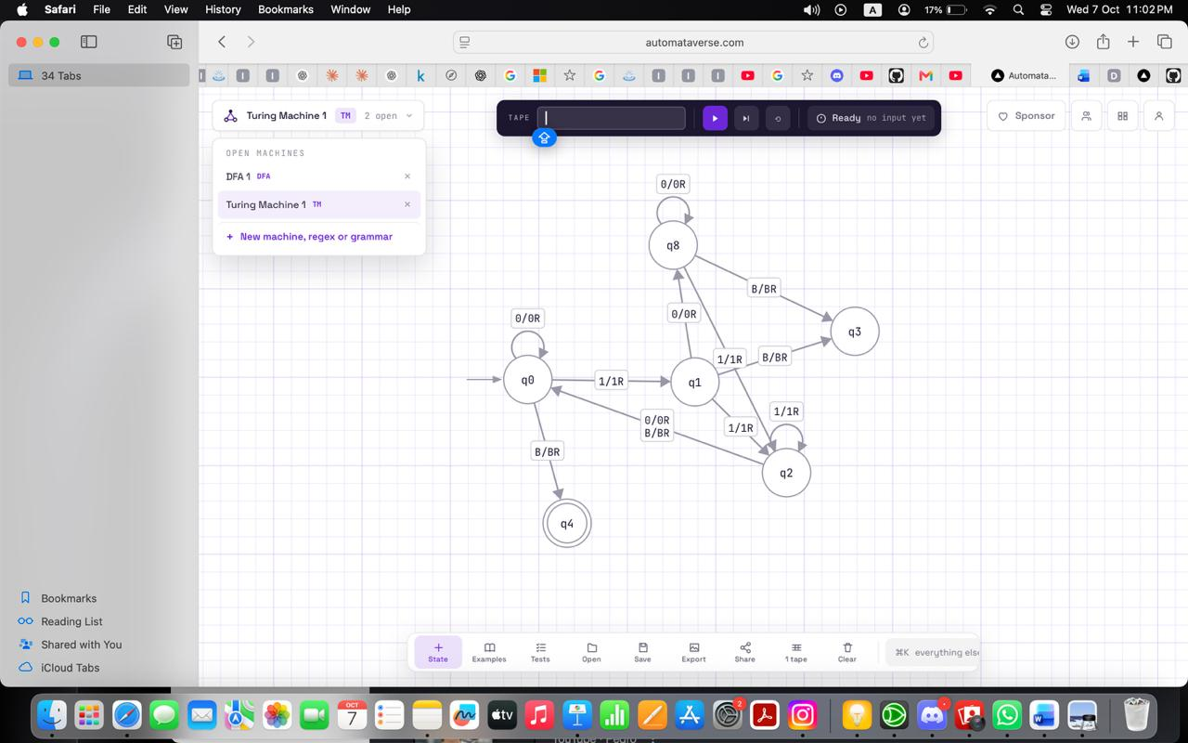
Task c)
- 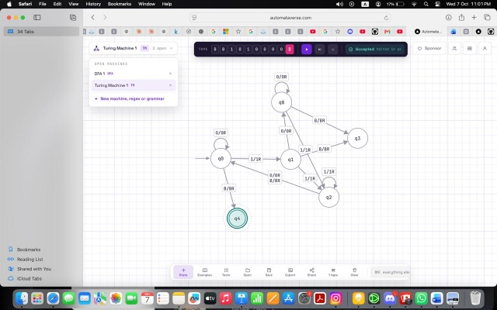

- 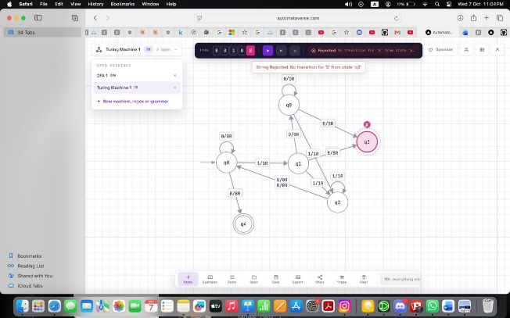

Task d) The machine is specifically designed to track the three possible remainders when dividing by 3 which are 0, 1, and 2. If M were changed, the machine would need a different set of remainder states and different transitions because the calculation of the new remainder would be based on modulo M

Q2 — Scaled-Count Recognizer
V = 0
N = 4

Task a) my Turing machine recognizes the language a^ⁿb^ⁿ by repeatedly matching one a with one b. It first scans from the left and marks an unmarked a as X, then moves right across the remaining a symbols and finds the first unmarked b, marking it as Y. The machine then returns to the left side of the tape and repeats this process until there are no unmarked a symbols left. At the end it checks that there are also no unmarked b symbols remaining; if both groups have been completely matched, it accepts, otherwise it rejects.

Task b)
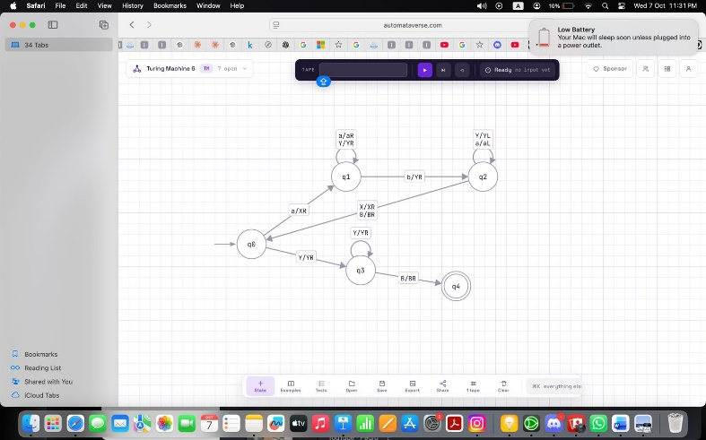

Task c)
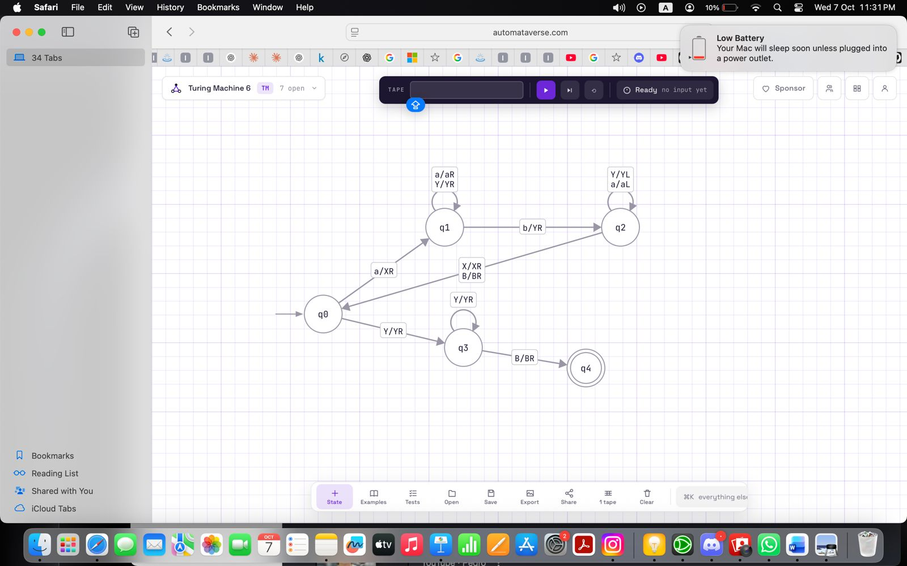
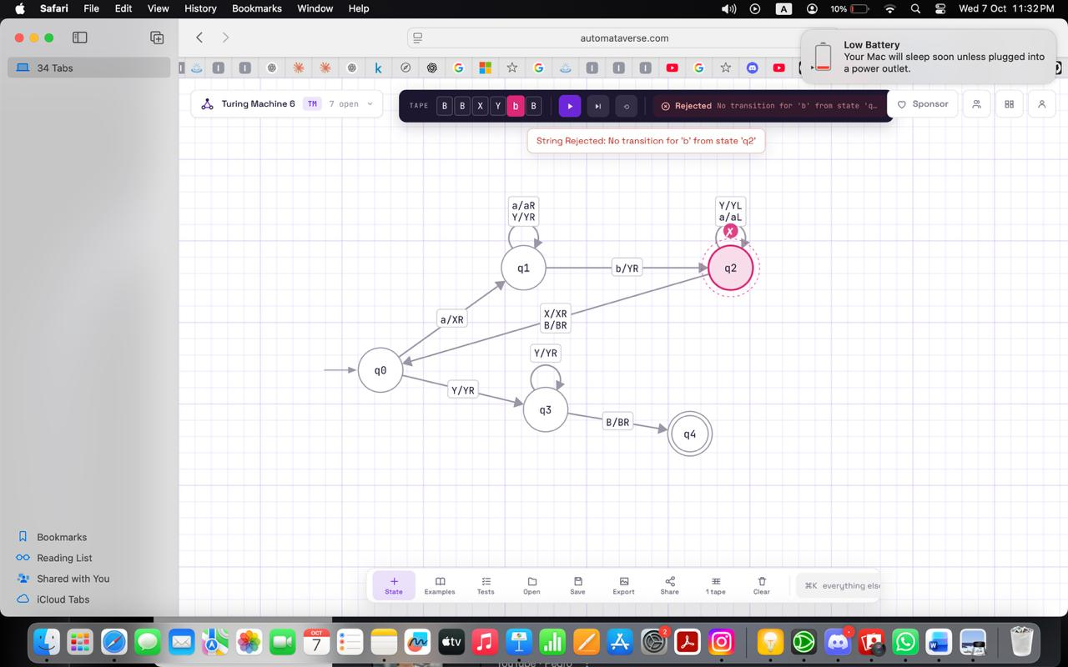

Task d) the most likely error occurs when the machine selects an a but accidentally skips or selects the wrong b while moving to the right to find its matching symbol. This could cause one a to be matched with two b or leave one a or b unmatched at the end.
Q3 — Binary Transformer
Task a) The Turing machine increments the binary number by 1 using the same carry process used in ordinary binary addition. It first moves the tape head to the right end of the binary number. It then changes a 0 to 1 and halts because no further carry is needed. If it encounters a 1, it changes that 1 to 0 and moves left continuing the carry until it finds a 0 and it changes to 1. If the machine reaches the blank on the left without finding a 0, it writes 1 at the front of the tape, handling numbers such as 111 becoming 1000.

Task b) 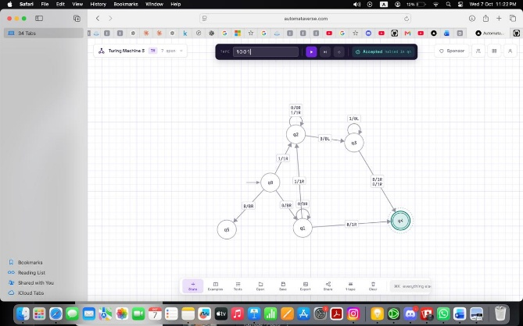

Task c)
- 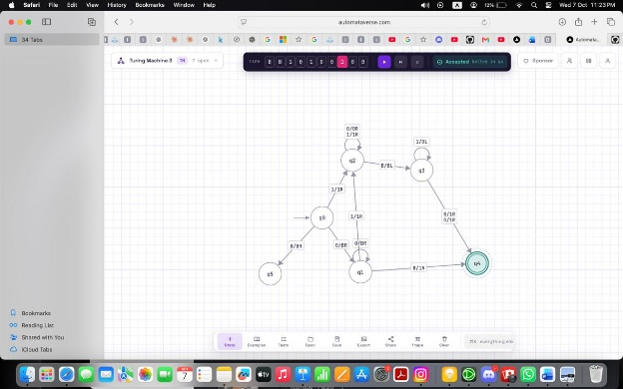
Personalize bit.
- 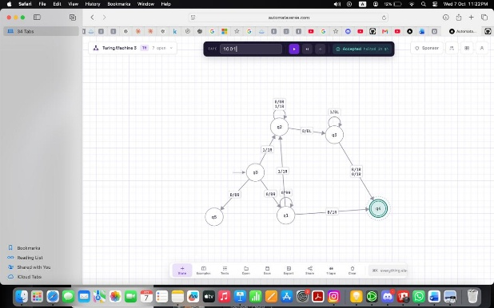
Bit string 1001.

Task d) The edge case 111 needs a carry through every bit as question 3 changes all three 1s to 0s and then writes 1 in the blank cell on the left, giving 1000. Changing only the leftmost bit would not be carried through the other positions and would not produce 8.

Q4 — Palindrome-Family Recognizer

Task a) The Turing machine checks whether a string over {a,b} is a palindrome by repeatedly comparing the outer unmatched symbols and moving inward. It marks the leftmost unmarked symbol and travels to the right end of the string and compares that symbol with the rightmost unmarked symbol. If the two symbols are different, the machine rejects and if they are the same, it marks the rightmost symbol and returns to the left side to repeat the process. The machine continues until all symbols have been matched.

Task b)
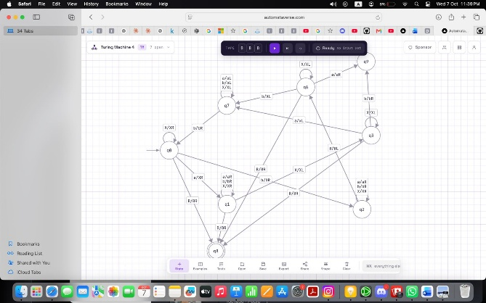

Task c)
- 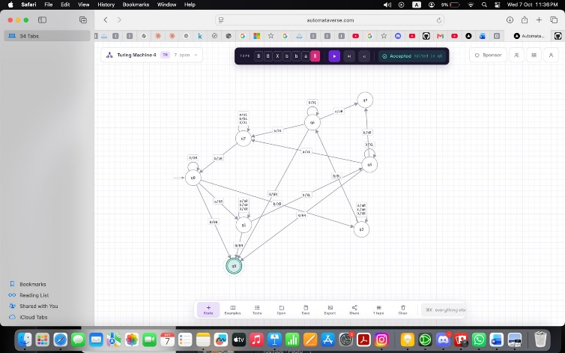

- 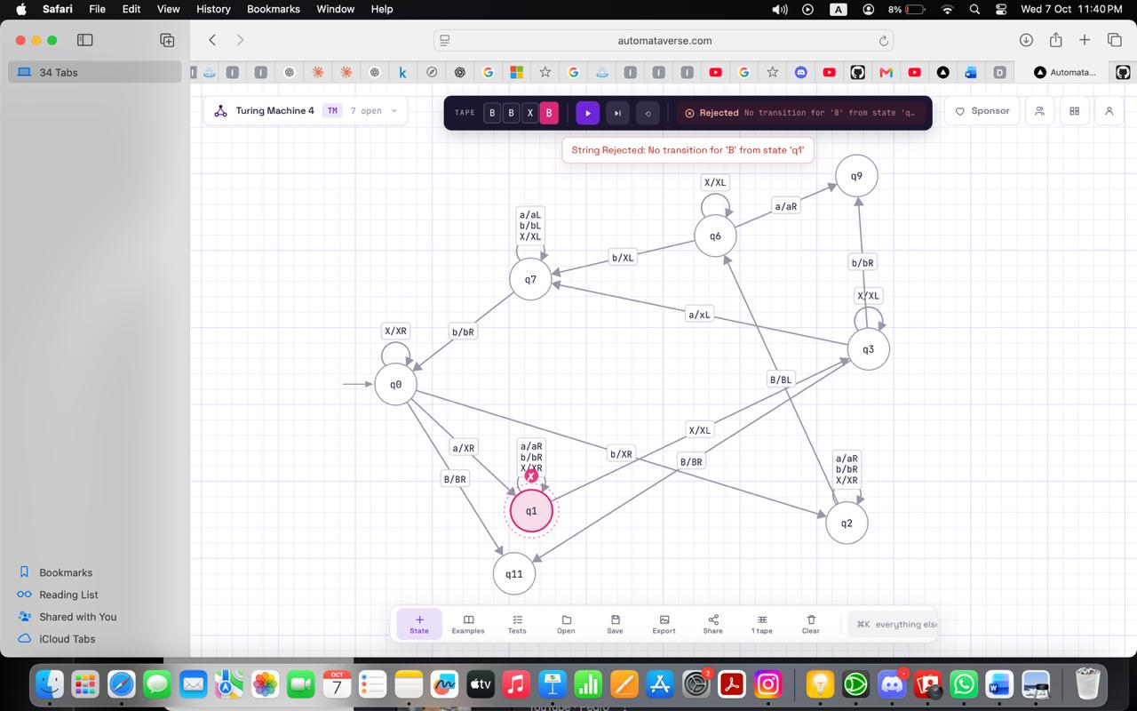

Task d) the State q1 remembers only one selected a while q2 remembers only one selected b butt neither can store a long first half. The rightward sweep finds that selected symbol's partner, and q7 must then sweep left to locate the next unmarked symbol. A single left to right pass would leave no way to revisit the earlier symbols when the matching suffix arrives.
Q5 — Marked-Comparison Recognizer

Task a) The Turing machine checks whether the string on the right side of # is exactly the same as the string on the left side. It repeatedly finds the leftmost unmarked symbol on the left side and remembers whether it was a 0 or 1 and then moves across # to find the next leftmost unmarked symbol on the right side. If the symbols match, it marks both of them and returns to the left side to repeat the process. If the symbols are different the machine rejects.
Task b)
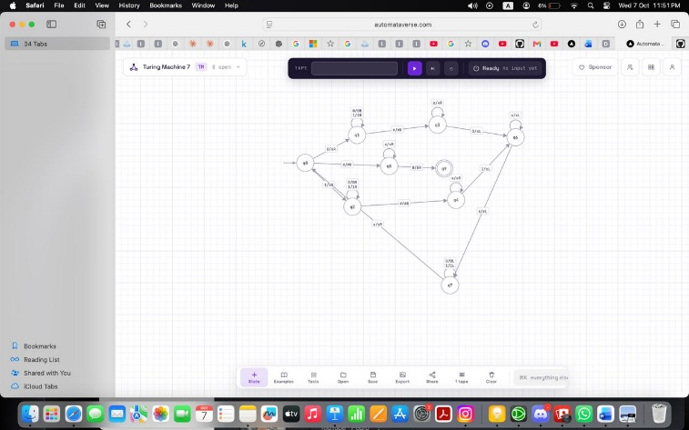

Task c)
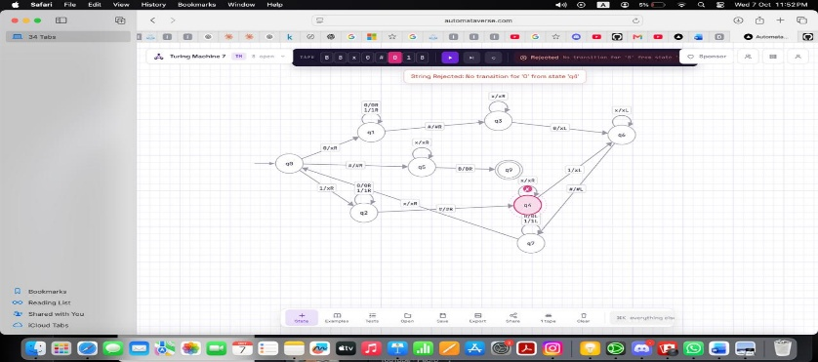

Task d) A single left to right pass is not enough because the machine needs to compare each symbol on the left with the belonging symbol on the right and the two copies can also be far apart. The machine would have to remember the entire left hand string while reading the right hand string which requires unbounded memory. Instead, the Turing machine marks one symbol at a time and moves back and forth across to compare the symbols. These repeated swaps allow the tape to store which positions have already been compared with each other.

Question no 6: Debug the Broken Machine.
Task A:

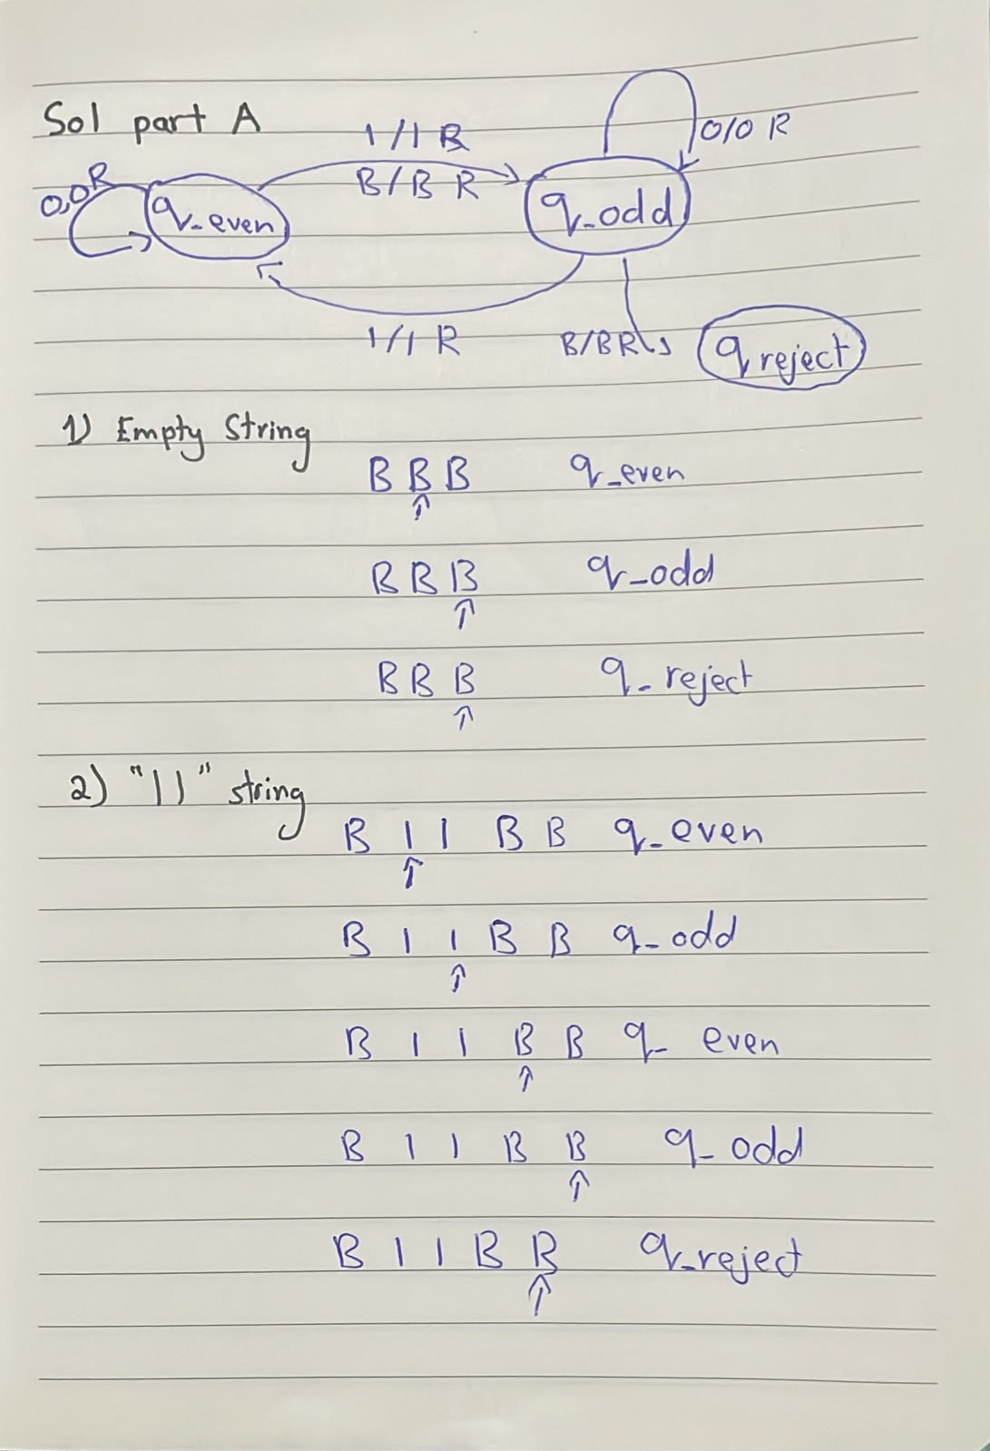

Task B:
The third row is incorrect because q_even moves to q_odd instead of q_accept. Even though
both inputs have an even length, the machine never reaches the q_accept state from q_even,
so the transition shown in that row is not correct.

Task C:
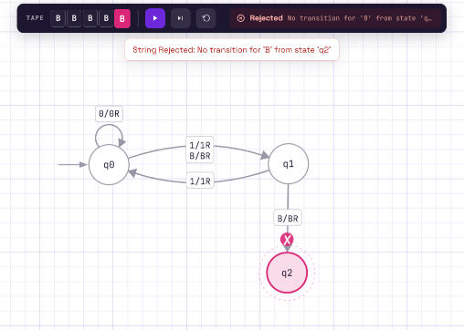Run 1

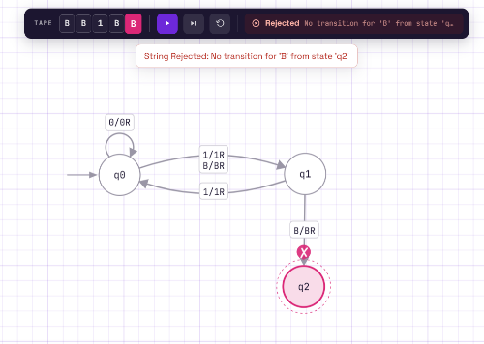Run 2

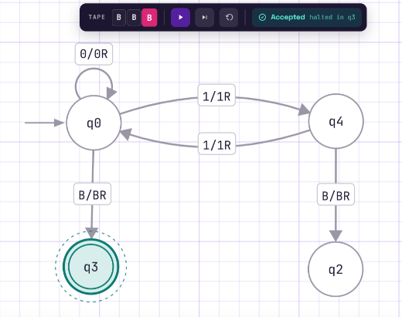Run 3

Task D:
Testing only with “1” and “111” would not have been enough because both inputs lead to the
rejected state. We were only able to notice the problem with the accept state after testing
inputs like “” and “11”. This shows that testing just a few examples can easily miss a bug in the
machine. To properly check the Turing machine, we need to test all possible types of inputs and
outcomes.

